**ManageVehicleCapability**

Topic: Vehicleinfo

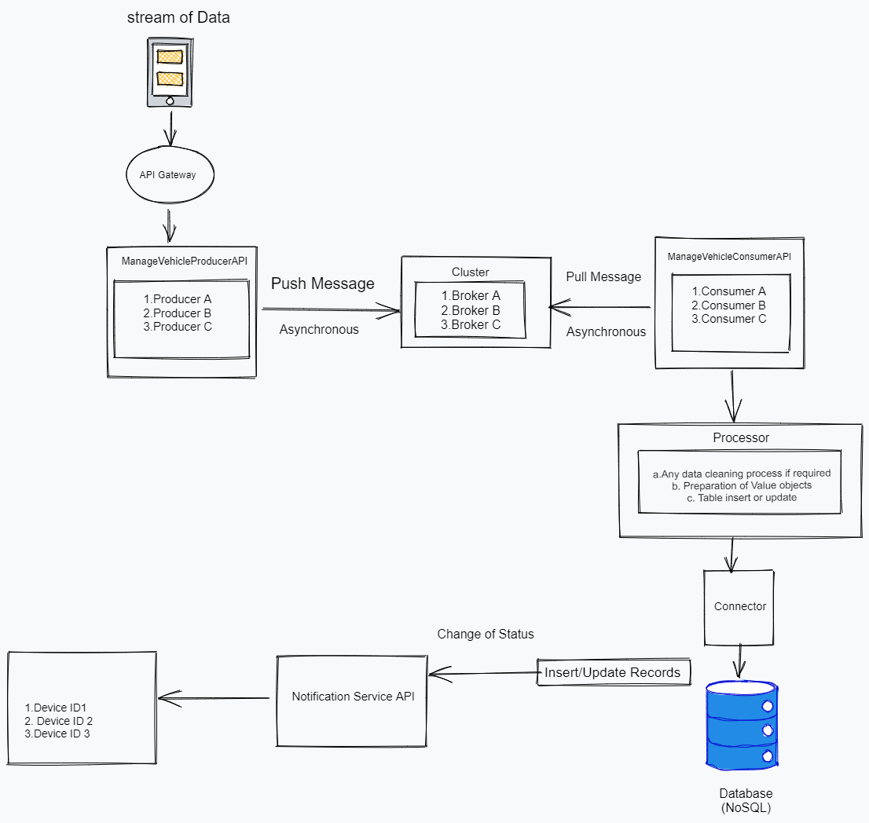

**Table data capture:**

1. Till the point we get the fields Make,ESU, VIN and ECU for the particular device id we won’t update the complete flag to “Y”.
2. Each time when we read the data and if the record (device id) already exists will update the

existing records and if there is a change will update the flag to “Change”.

|  |  |  |  |  |  |  |  |
| --- | --- | --- | --- | --- | --- | --- | --- |
| Device ID | Make | ESU | VIN | ECU | Time stamp | Version | Complete |
| 1 | Toyota | 12 | 67 | 12 | 11:15 | v1.0 | Y |
| 2 | Nissan | 56 | 89 | 0 |  | v1.1 | N |
| 3 | BMW | 777 | 9 | 11 |  | V1.0 | N |
|  |  |  |  |  |  |  |  |